MEHRAN UNIVERSITY

OF ENGINEERING & TECHNOLOGY

JAMSHORO, PAKISTAN

Design the network and apply the knowledge of routing protocol to configure the OSPF protocol in network.

Subject: COMPUTER NETWORKS (PR)

(Lab 11 - Tasks Solution)

|  |  |
| --- | --- |
| **Roll No:** | **22SW028** |
| **Section:** | **I** |

**LAB TASKS:**

**NETWORK CONFIGURATION:**

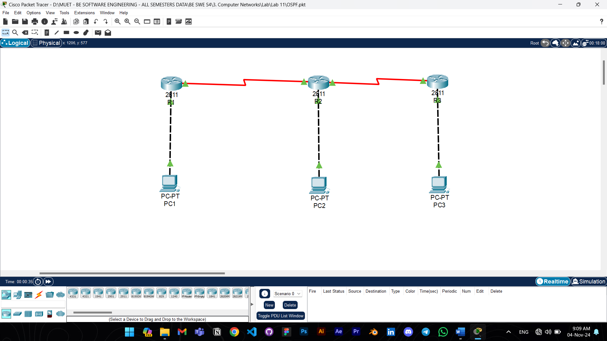

The network was built using 3 routers working on OSPF routing protocol.

Answers to the questions given in Lab Manuals are below.

**Answers to Questions:**

**Q1: If an interface gets down, will it retain the IP address or not?**

Ans: Yes, an interface will retain its IP address even if it goes down. However, the IP address will not be accessible until the interface is brought back up.

**Q2: Why do routers reflect only network addresses in the routing table?**

Ans: Routers reflect only network addresses in the routing table because they are primarily concerned with routing packets to specific networks rather than individual hosts. This helps in optimizing memory and processing power by keeping routing tables concise.

**Q3: What does /65 represent in the OSPF routing table entry?**

Ans: In an OSPF routing table entry, the /65 does not indicate a subnet mask but rather an OSPF cost metric. This metric is a value calculated by OSPF to determine the cost of a route. Lower metrics indicate preferred routes. In this context, 65 represents the total cost to reach the destination network via a specific interface.

**Q4: List the remote routes listed in the routing table of Router2.**

Ans: The remote routes in the routing table of Router2 are:

192.168.1.0/24 [110/65] via 192.168.0.1, Serial0

192.168.3.0/24 [110/65] via 172.16.0.2, Serial1

These routes are learned from other routers via the OSPF protocol, indicating they are not directly connected to Router2 but are accessible through other routers.

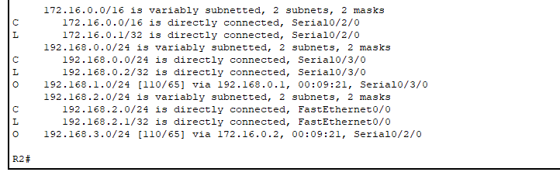

**Checking Connectivity:**

**From PC1 to PC2:**

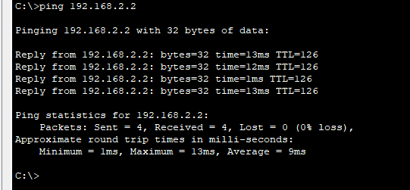

**From PC1 to PC3:**

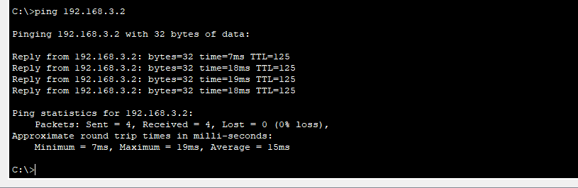

Note: The configuration commands aren’t added in the tasks as they are already present in the manual. The packet tracer file of the following task is also attached with the assignment.